**What's the history behind April 28?**

Remember the Canary!

April 28 has many names. In Canada, it’s the Day of Mourning. In the United States and the United Kingdom, it’s Workers’ Memorial Day. The International Labour Organization calls it the World Day for Safety and Health at Work. Marked around the world, there’s confusion about its origins, even in Canada.

About 1983, the health and safety director of the Canadian Union of Public Employees (CUPE), Colin Lambert, and his long-time friend and fellow activist, Ray Sentes, came up the idea of a day to recognize workers killed and injured on the job.

As a steelworker and miner in Sudbury, Ontario, Lambert was instrumental in having mandatory coroners’ inquests for all miners’ deaths in Ontario (Canada). He also lamented the contrast between the lack of recognition or memorials for miners and other workers who died on the job or because of their work and public events for “fallen” police officers and fire fighters.

Lambert “floated the idea” with CUPE’s national health and safety committee, talking about a special day of recognition for workers killed and injured on the job, to be held on May 1 (celebrated as May Day in Europe and elsewhere). The committee endorsed the idea. At its 1984 convention, union delegates supported the proposal. Soon after, some CUPE locals started negotiating events, such as lowered flags and moments of silence.

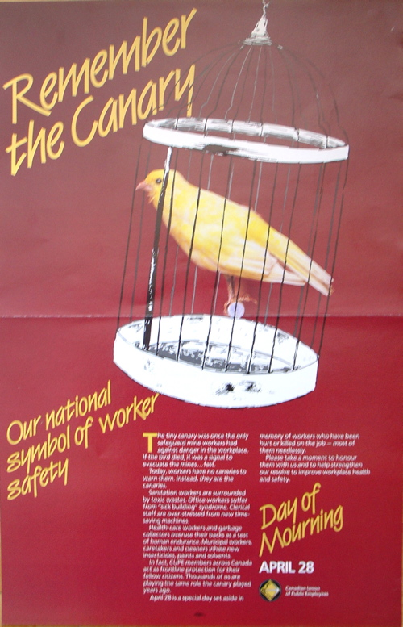In 1984 and 1985, CUPE representatives took the idea to the Canadian Labour Congress (CLC) executive and its national health and safety committee. Local unions also sent resolutions to the CLC.

In February 1986, the CLC announced the first Day of Mourning, coinciding with the first day of its convention that year. Rather than May 1, they chose the date when the Ontario legislature passed the country’s first workers compensation law, in 1914. The convention passed a resolution supporting April 28 as a day to "mourn for the dead and fight for the living."

In 1990, Lambert and CUPE pushed for innovative ways to recognise the day. April 28 could be a “year-round series of *public* events”, not just a Day of Mourning. We can attract “broad public recognition for the day by adopting a universal, unthreatening symbol of worker safety, the canary.”

 “The canary’s an appropriate symbol,” Lambert said. “It shows that today workers are the canaries -- they are front-line protection for all of us.” The canary also showed up in the CLC’s new poster for April 28.

Lambert and others saw the potential for a day of “preventive action for workers which will be recognized by society in general.” They called on CUPE locals to have activities in the week heading up to the 28th. They sent a package with a new poster -- introducing the canary symbol -- and a special issue of the health and safe newsletter. There also was a workplace inspection checklist and calls for locals to campaign for government recognition of the day and to bargain or ask employers for a moment’s silence at 11 a.m. on April 28.

CUPE members and others responded with enthusiasm. The British Columbia CUPE health and safety committee had a “Spot the Hazard” campaign for workplace inspections. In Winnipeg, Manitoba, the Federation of Labour and CUPE produced tags with the canary symbol and “Day of Mourning, April 28”. They sold them with members of the local professional football team and the Boys and Girls Club, with proceeds to the Club. In Windsor, Ontario, more than 300 people marched to the Ministry of Labour to lay a wreath and release black balloons inscribed with “We came here to work, not to die”.

The campaign for government recognition paid off. In February 1991, the Canadian government passed a private member’s bill, naming April 28 as the "Day of Mourning for Persons Killed or Injured in the Workplace.” Provincial and municipal governments also recognize the day.

These efforts, and many others, inspired trade unions and health and safety activists and around the world. Monuments and plaques are some of the most common responses. There were so many by 2001 that Ed Thomas of Hamilton wrote a book about them -- "Dead But Not Forgotten–Monuments to Workers." The Canadian Centre for Occupational Health and Safety (CCOHS) put some of his pictures on a web page (<http://www.ccohs.ca/events/mourning/photolinks.html>).

The campaign for recognition of the day has been successful. Now what about the goals behind it?

# From: *Occupational Health and Safety Section Newsletter*, Spring 2010, at <http://www.apha.org/membergroups/newsletters/sectionnewsletters/occupat/spring10/default.htm#{378CB4CC-E231-4ED5-A497-17AFFA1C6336}>

- Dorothy Wigmore

APHA OHS Section Secretary